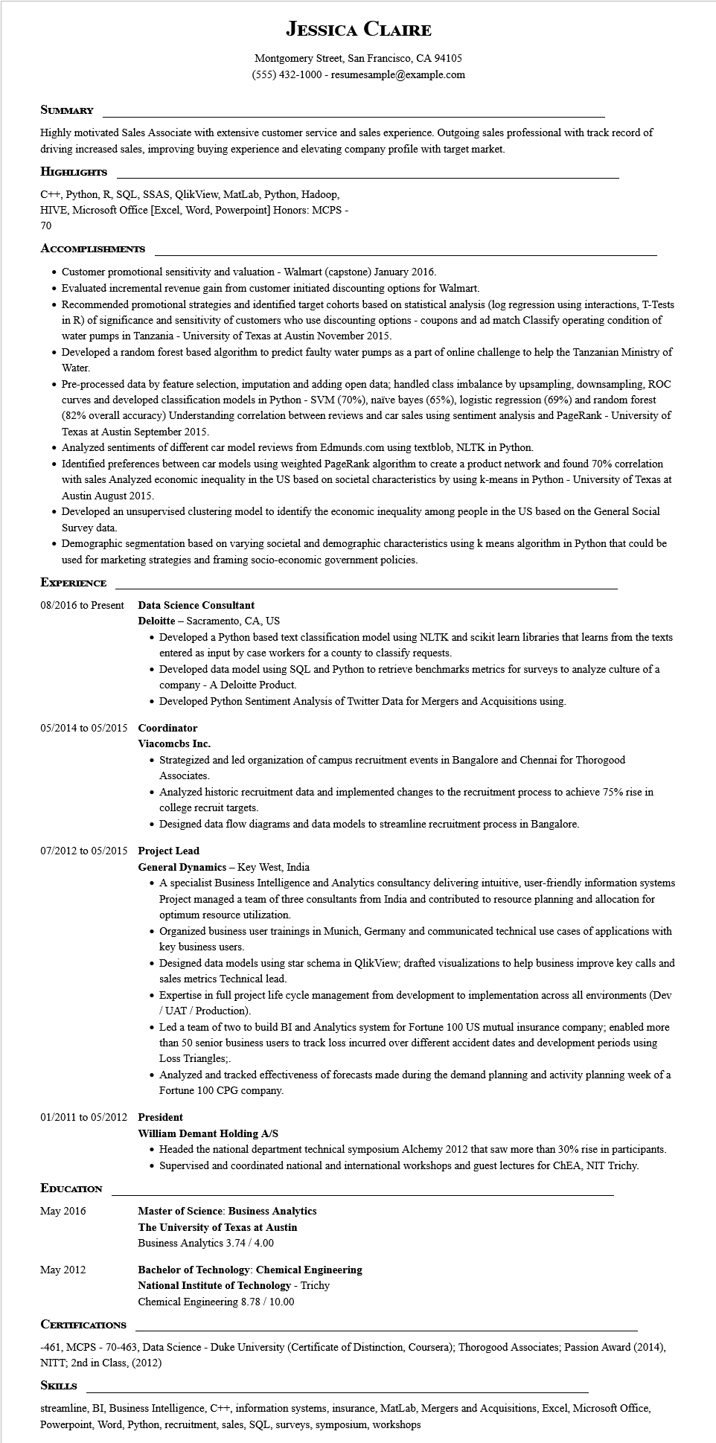
JESSICA CLAIRE
Montgomery Street, San Francisco, CA 94105
(555) 432-1000 - resumesample@example.com
SUMMARY
Highly motivated Sales Associate with extensive customer service and sales experience. Outgoing sales professional with track record of driving increased sales, improving buying experience and elevating company profile with target market.
HIGHLIGHTS
C++, Python, R, SQL, SSAS, QlikView, MatLab, Python, Hadoop,
HIVE, Microsoft Office [Excel, Word, Powerpoint] Honors: MCPS -
70
ACCOMPLISHMENTS
• Customer promotional sensitivity and valuation - Walmart (capstone) January 2016.
• Evaluated incremental revenue gain from customer initiated discounting options for Walmart.
• Recommended promotional strategies and identified target cohorts based on statistical analysis (log regression using interactions, T-Tests
in R) of significance and sensitivity of customers who use discounting options - coupons and ad match Classify operating condition of water pumps in Tanzania - University of Texas at Austin November 2015.
• Developed a random forest based algorithm to predict faulty water pumps as a part of online challenge to help the Tanzanian Ministry of Water.
• Pre-processed data by feature selection, imputation and adding open data; handled class imbalance by upsampling, downsampling, ROC curves and developed classification models in Python - SVM (70%), naïve bayes (65%), logistic regression (69%) and random forest (82% overall accuracy) Understanding correlation between reviews and car sales using sentiment analysis and PageRank - University of Texas at Austin September 2015.
• Analyzed sentiments of different car model reviews from Edmunds.com using textblob, NLTK in Python.
• Identified preferences between car models using weighted PageRank algorithm to create a product network and found 70% correlation with sales Analyzed economic inequality in the US based on societal characteristics by using k-means in Python - University of Texas at Austin August 2015.
• Developed an unsupervised clustering model to identify the economic inequality among people in the US based on the General Social Survey data
• Demographic segmentation based on varying societal and demographic characteristics using k means algorithm in Python that could be used for marketing strategies and framing socio-economic government policies.
EXPERIENCE
08/2016 to Present
Data Science Consultant
Deloitte - Sacramento, CA, US
• Developed a Python based text classification model using NLTK and scikit learn libraries that learns from the texts entered as input by case workers for a county to classify requests.
• Developed data model using SQL and Python to retrieve benchmarks metrics for surveys to analyze culture of a company - A Deloitte Product.
• Developed Python Sentiment Analysis of Twitter Data for Mergers and Acquisitions using.
05/2014 to 05/2015 Coordinator
Viacomcbs Inc.
• Strategized and led organization of campus recruitment events in Bangalore and Chennai for Thorogood Associates.
• Analyzed historic recruitment data and implemented changes to the recruitment process to achieve 75% rise in college recruit targets.
• Designed data flow diagrams and data models to streamline recruitment process in Bangalore.
07/2012 to 05/2015 Project Lead General Dynamics - Key West, India
• A specialist Business Intelligence and Analytics consultancy delivering intuitive, user-friendly information systems Project managed a team of three consultants from India and contributed to resource planning and allocation for optimum resource utilization.
• Organized business user trainings in Munich, Germany and communicated technical use cases of applications with key business users.
• Designed data models using star schema in QlikView; drafted visualizations to help business improve key calls and sales metrics Technical lead.
• Expertise in full project life cycle management from development to implementation across all environments (Dev /UAT/Production).
• Led a team of two to build BI and Analytics system for Fortune 100 US mutual insurance company; enabled more than 50 senior business users to track loss incurred over different accident dates and development periods using Loss Triangles;.
• Analyzed and tracked effectiveness of forecasts made during the demand planning and activity planning week of a Fortune 100 CPG company.
01/2011 to 05/2012 President
EDUCATION
May 2016
William Demant Holding A/S
• Headed the national department technical symposium Alchemy 2012 that saw more than 30% rise in participants. • Supervised and coordinated national and international workshops and guest lectures for ChEA, NIT Trichy.
Master of Science: Business Analytics
The University of Texas at Austin
Business Analytics 3.74 / 4.00
May 2012
Bachelor of Technology: Chemical Engineering
National Institute of Technology - Trichy
Chemical Engineering 8.78 / 10.00
CERTIFICATIONS
-461, MCPS - 70-463, Data Science - Duke University (Certificate of Distinction, Coursera); Thorogood Associates; Passion Award (2014), NITT; 2nd in Class, (2012)
SKILLS
streamline, BI, Business Intelligence, C++, information systems, insurance, MatLab, Mergers and Acquisitions, Excel, Microsoft Office, Powerpoint, Word, Python, recruitment, sales, SQL, surveys, symposium, workshops

